

**RESEARCH AGENDA**

**(2018-2022)**



|  |  |
| --- | --- |
| **CHAPTER** | **PAGE** |
| 1. Foreword | 1 |
| 2. Introduction | 2 |
| 3. Framework and Documents Reviewed for Research Agenda Setting | 3 |
| 3.1. Framework used in the Research Agenda Setting Process | 3 |
| 3.2. Documents Reviewed for Research Agenda Setting | 4 |
| 3.2.1. Sustainable Development Goals | 5 |
| 3.2.2. National harmonized Research and Development Agenda (2018-2022) | 6 |
| 3.2.3. Ambisyon Natin 2040 | 8 |
| 3.2.4. National Unified Health Research Agenda | 8 |
| 3.2.5. National Higher Education Research Agenda 1 and 2 | 10 |
| 3.2.6. The Philippine Plan for Gender-Responsive Development | 11 |
| 3.2.7. DOST Region 3 Research Agenda | 11 |
| 3.2.8. Deped Region 3 Reformulated Regional Research Agenda | 12 |
| 4. Tarlac State University’s Ten Research Agenda | 13 |
| 4.1. Research Agenda Setting | 13 |
| 4.2. The University’s Ten Research Agenda (2018-2022) | 13 |
| 4.2.1. Environment and Climate Change Mitigation and Adaptation | 14 |
| 4.2.2. Food Safety, Security and Innovation | 14 |
| 4.2.3. Industry, Energy and Emerging Technologies | 15 |
| 4.2.4. Public Policy and Social Praxis | 15 |
| 4.2.5. Design and Validation of Software | 16 |
| 4.2.6. Gender and Development Studies | 16 |
| 4.2.7. Inclusive Education and Educational Reform | 17 |
| 4.2.8. Language, Arts, History, and Culture | 17 |

Table

of

Contents

|  |  |
| --- | --- |
| **CHAPTER** | **PAGE** |
| 4.2.9. Responsive Health Sysytem | 18 |
| 4.2.10. Business Accounting and Economic Advancement | 18 |
| 5. Appendices | 19 |
| List of Completed Researches under the Previous Research Agenda (2015-2017) | 19 |
| List of Completed and on-going researches under the Ten (10) Research Agenda (2018-2019) | 27 |
| Copy of the Invitation Letters sent to the TSU Stakeholders | __ |
| Copy of the Program during the Research Agenda Setting | __ |
| Copy of the Attendance sheets during the Research Agenda Setting | __ |
| Sample Pictures taken during the Research Agenda Setting | __ |

Tarlac State University (TSU) is a public university located in Tarlac City, Philippines. Established in 1906, it is a premier academic institution of higher learning in the province offering different degree programs through its ten (10) colleges and four (4) campuses.

As a State University, TSU is governed by the mandates of the Commission on Higher Education (CHED). TSU maintain its quality tertiary education by performing four (4) main functions particularly instruction, extension, production and Research. Research has been one of the priorities of the University since its first operation as a State University. This was evident by the generation of quality researches that aided in the provincial, regional and national development.

This material presents the research agenda of Tarlac State University for the year 2018 to 2022. The new research agenda provides the concrete direction of the University in terms of research and development for the next five (5) years. The University’s Research Agenda are anchored on the United Nation’s seventeen (17) sustainable development goals, the Department of Science and Technology’s National Harmonized Research and Development Agenda, the National Economic Development Authority’s AMBISYON 2040, the CHED’s National Higher Education Research Agenda, the Department of Health’s National Unified Health Research Agenda, the Regional Science and Technology Research Agenda, and the Regional Reformulated Research Agenda for Education.

1. Foreword

1

2

Research agenda plays a vital role in helping design research activities for faculty as well as graduate and undergraduate students. Having a well-defined research agenda help a University identifies research priorities. It also outline a concrete framework for guided decision making in terms of future research activities and undertakings.

Having this on mind, the executive committee of Tarlac State University headed by Dr. Myrna Q. Mallari, conducted a three-in-one event last March 23, 2018 to craft the five-year research agenda and priority programs of the University. Participatory approach to planning and decision making was integrated. Various stakeholders from the Department of Science and Technology, Department of Environment and Natural Resources (DENR), Provincial Environment and Natural Resources Office (PENRO), Community Environment and Natural Resources Office (CENRO), Provincial Government, Local Government Units, Tarlac Agricultural University (TAU), students and faculty attended the activity and help in the formulation of the University’s Research Agenda.

After the successful conduct of the activity, ten (10) research agenda were identified namely; (1) Environment and Climate Change Mitigation and Adaptation, (2) Food Safety Security, and Innovation, (3) Industry, Energy, and Emerging Technologies, (4) Design, Development and Validation of Software, (5) Gender and Development Studies, (6) Public Policy and Social Praxis, (7), Business Accountancy and Economic Advancement, (8) Inclusive Education and Educational Reform, (9) Language, Arts, History and Culture, and (10) Responsive Health System.

The identified research agenda has been inculcated to the researches produced and will be produced by the University.

2.Introduction

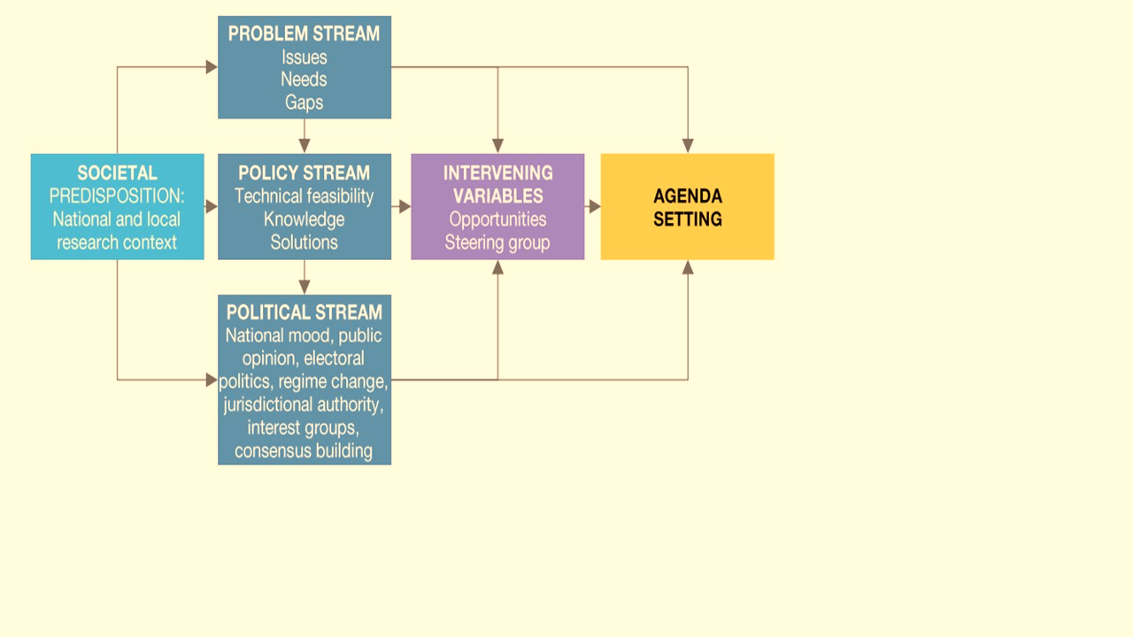

3. Framework and Documents Reviewed for Research Agenda Setting

The Kingdon Multiple Streams Model on Agenda Setting was integrated in the process. The model was based on societal predisposition in determining problem stream, policy stream and political stream before the actual formulation of the University’s research agenda. Societal predisposition focuses on the context of national and local researches. For this reason, the national research agenda of the Department of Science and Technology, AMBISYON 2040 of the National Economic Development Authority as well as the regional research agenda for science, technology and education were incorporated on the agenda. Figure 1 depicts the Kingdon Multiple Stream Model on Agenda Setting.

**3.1. FRAMEWORK USED IN THE RESEARCH AGENDA SETTING PROCESS**

3

**Figure 1.** A Flowchart Illustrating the Kingdon Multiple Streams Model on Agenda Setting

**3.2. DOCUMENTS REVIEWED FOR RESEARCH AGENDA SETTING**

**Figure 1.** A Flowchart Illustrating the Kingdon Multiple Streams Model on Agenda Setting (1984)

Aside from the issues and needs of the University’s stakeholders, the research agenda of TSU represents the interest of the international, national, as well as regional needs and priority areas. Presented in Figure 2, the organization and government instrumentalities used as a basis for the TSU’s Research Agenda.

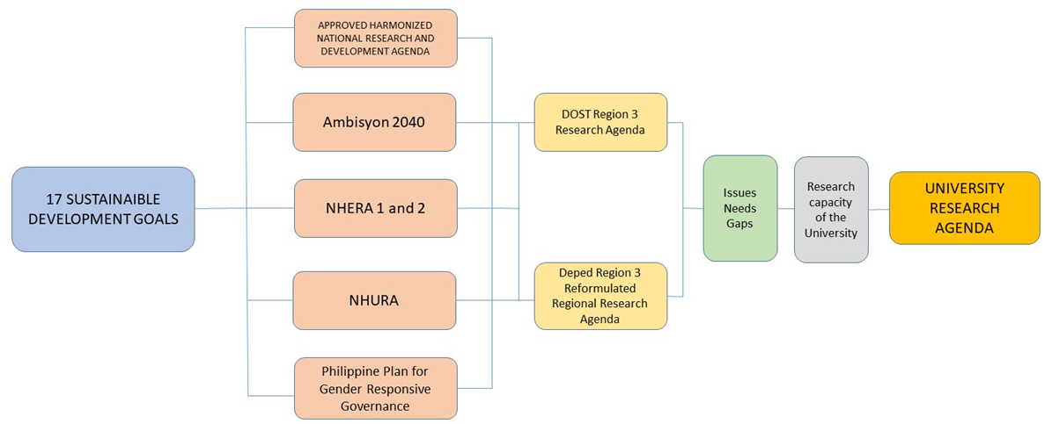

4

**Figure 2.** Instrumentalities used as a basis for TSU’s Research Agenda

**3.2.1. Sustainable Development Goals**

In 2015, member states of the United Nations adapted the 2030’s Agenda for Sustainable Development. The agenda provides a shared plan for peace, prosperity, people and the planet. The agenda has seventeen (17) core goals which are imperative and urgent call for action by all developed and developing countries. The 17 Sustainable Development Goals (Figure 3) recognize the essentiality of ending poverty and any other forms of deprivations through strategies that improve health and education, lessen inequality and stimulate economic progress – all while preserving our oceans and forest and addressing the impacts of climate change.

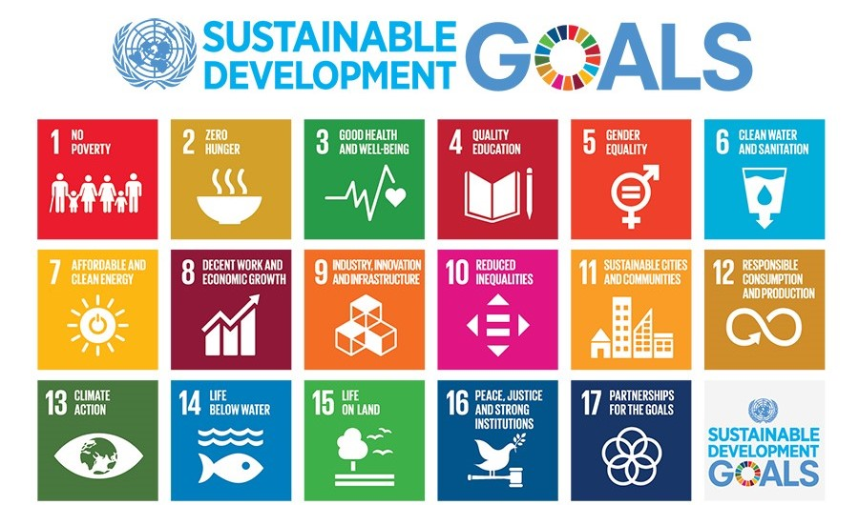

5

**Figure 3.** The 17 Sustainable Development Goals

As a prominent member of the United Nations, the Philippines adopted the principles of the sustainable development goals on its social, economic and environmental programs. In terms of its research and development undertakings, the SDGs serve as the core for its planning, prioritization, and decision making.

Similarly, TSU recognizes the importance of the seventeen (17) sustainable development goals in reducing poverty, ending inequality, enhancing economic progress and conserving the natural resources. Hence, TSU offers researches on empowering micro, small and medium enterprises (SMEs), gender and development, educational reforms, responsive health systems, environmental protection and climate change mitigation and adaptation.

**3.2.2. Harmonized National Research and Development Agenda (2017-2022)**

The DOST serve as the main arm in providing central direction, leadership, and coordination of scientific and technological efforts of the country. In 2017, the DOST formulated and finalizes the Harmonized National Research and Development Agenda (HNRDA) for the year 2017 to 2022. The HNRDA was crafted in consultation with government and private research and development institutions, the academe, industry and other concerned agencies. The detailed research and development priority areas and programs of the HNRDA is presented in Figure 4. Priority researches under the HNRDA is categorized on Basic Research, Agriculture Aquatic and Natural Resources, Health, Industry, Energy and Emerging Technology, and Disaster Risk Reduction and Climate Change Adaptation.

As a research academic institution, the TSU adopted the research priority programs of the HNRDA reflecting them on its 5-year research agenda. TSU endeavors to produce researches on the areas of industry, energy, and emerging technology, health, clean energy, food and nutrition security, and on disaster risk reduction and management.

6

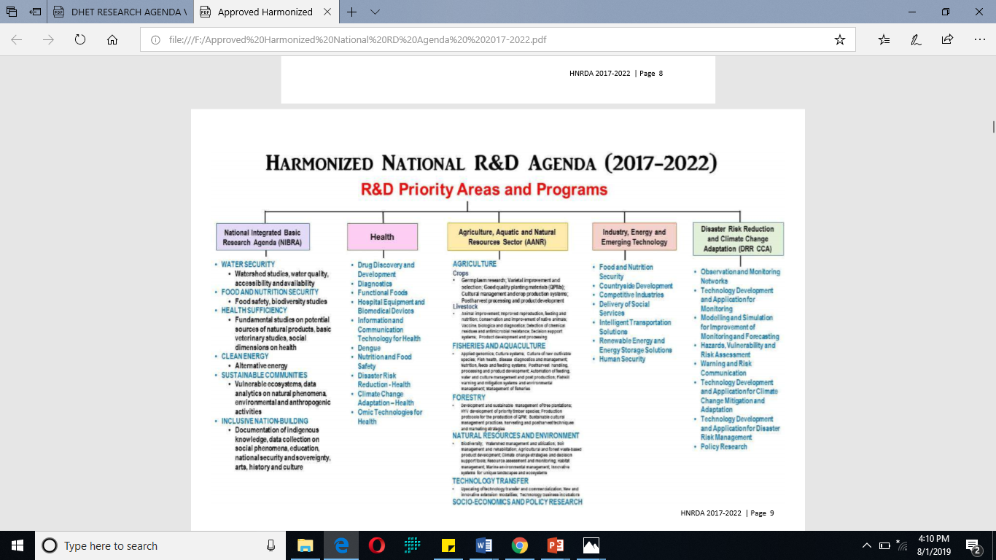

**Figure 4**. HNRDA R&D Priority Areas and Programs

7

**3.2.3. AmBisyon Natin 2040**

The

**2.2. Harmonized National Research and Development Agenda (2017-2022)**

The NEDA’s AmBisyon Natin 2040 depicts the collective long-term vision and aspirations of the Filipino people for themselves and for the country in the next 25 years. It describes the kind of life that people want to live, and how they want the country to be by the end of 2040. It has three major pillars: Malasakit (enhancing the social fabric), Pagbabago (reducing inequality) and Kaunlaran (increasing potential growth). AmBisyon Natin 2040 and the three pillars form the foundation for a more inclusive growth, a high-trust and resilient society and a globally competitive knowledge economy.

The DOST’s HNRDA is aligned to the attainment of the Ambisyon Natin 2040.Figure 5 presents the working framework of the HNRDA and Ambisyon Natin 2040.

TSU upholds and supports the goals of the Ambisyon Natin 2040. The University believed that it is through research and development where Filipinos can attain a more comfortable and progressive life. Thus, the research trust of the University is moving toward the development of cost-effective technologies, cleaner energy, including marketing researches for local products and entrepreneurs.

**3.2.4. National Unified Health Research Agenda**

The National Unified Health Research Agenda (NUHRA) provides a concrete guide on health research and development efforts of the country and given recent developments on the local health economy. The different research priorities of the NUHRA is presented in Figure 5.

8

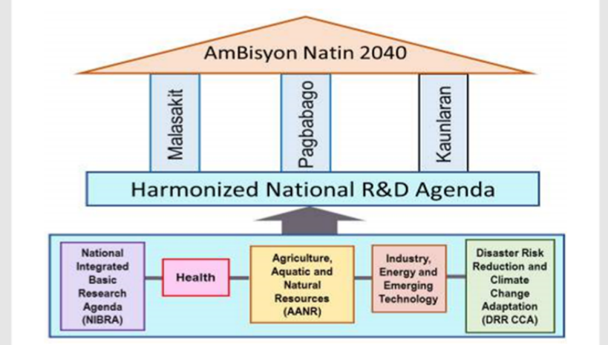

**Figure 4**. HNRDA R&D Priority Areas and Programs

The Tarlac State University recognizes the importance of health-related researches in promoting public health. For this reason, the university adopted the different priority programs under the NUHRA to become one of the bases in crafting its research agenda.

9

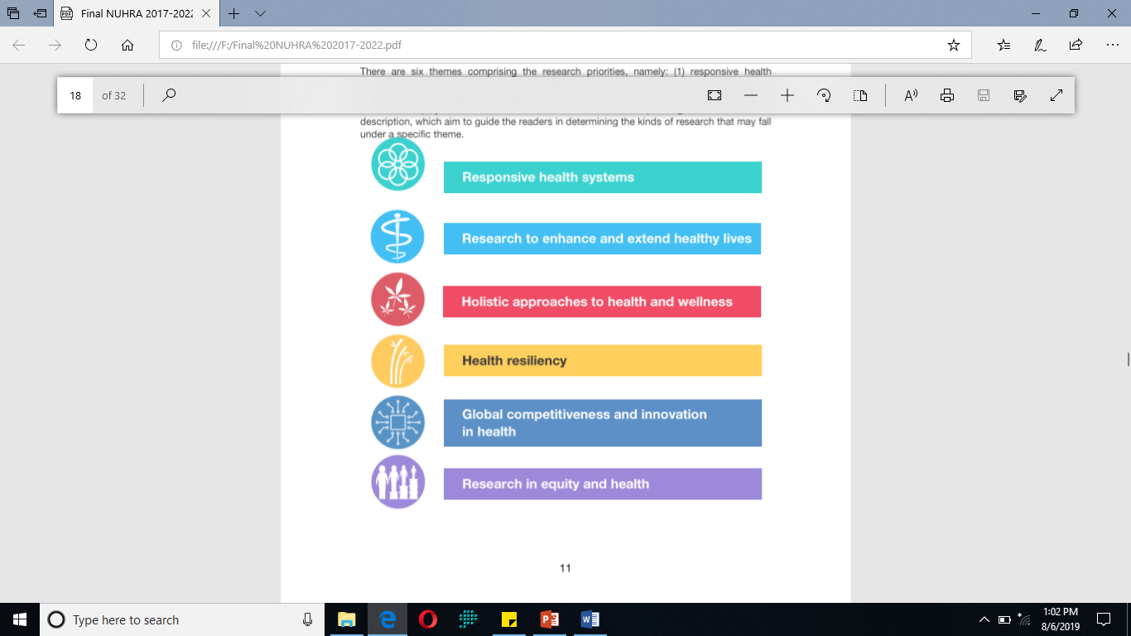

**Figure 5**. Research Priorities under the National Unified Health Research Agenda

**3.2.5. National Higher Education Research Agenda 1 and 2**

The National Higher Education Research Agenda (NHERA) provides strategies and initiatives to develop research capacity and enhance research productivity in higher education institutions. The NHERA also identifies priority areas for

10

research and research-related programs in the next ten years.

As a Higher Education Institute, the Tarlac State University upholds the importance of promoting research needed for the advancement of higher education as well as for national development. It is with this reason that the four research agenda of the NHERA were used as a basis in crafting the University’s research agenda for the year 2018-2022.

**3.2.6. The Philippine Plan for Gender-Responsive Development**

The Philippine Plan for Gender-Responsive Development (PPGD) rest on a vision of development that is equitable, sustainable, free from violence, respectful of human rights, participatory and empowering. The PPGD puts greater emphasis on women as a disadvantage group.

The Tarlac State University is always on the frontline of supporting and empowering the rights of women as well as persons with disability. Hence, the PPGD as well as the policies and guidelines embedded in CHED Memo No.1 s. 2015 were the bases in crafting the research agenda of the University particularly on gender and development studies.

**3.2.7. DOST Region 3 Research Agenda**

The Tarlac State University recognizes the important role of research in regional development. Hence, on crafting its research agenda, the priority research programs and

.

11

programs of the .DOST Region III was consulted and become an integral component of the agenda setting. The research priority programs of DOST region 3 focuses on competitive and innovative industry and services sector, competitive and sustainable agriculture and fisheries, accelerating social development as well as the conservation and rehabilitation of the environment and natural resources.

**12**

The Tarlac State University acknowledges the salient role of basic education research in regional development. It is for this reason that the reformulated research agenda of the DepEd Region III was integrated in the formulation of the University’s research agenda for the 2018 to 2022. Like the Department of Education, the University also supported and upholds researches on teaching and learning, child protection, human resource development as well as on good governance.

.

**3.2.8. Department of Education (DepEd) Region 3 Reformulated Regional Research Agenda**

Research remain as one of the frontline functions of the Tarlac State University, The University endeavors to provide researches that are relevant and contributory to the regional and national development.

In March 2018, through a participatory method of agenda setting, a total of 50 stakeholders of the University gathered together to formulate the University’s research agenda for the year 2018 to 2022. The research agenda were primarily anchored on the 17 sustainable development goals of the United Nation as well as on President Duterte’s Philippine Development Plan. The research agenda were also based on the research priority programs of the DOST, NEDA, DOH as well as the CHED.

The new research agenda provides basis and direction for the University on its research undertakings. This was also cascaded to the different colleges of the University for them to align their researches within the boundaries of the formulated research agenda.

The new ten (10) research agenda of the University covers a wide spectrum of researches from combating the impacts of climate change to enhancing the information-based of business accounting towards economic advancement.

**4.1. Research Agenda Setting**

4. Tarlac State University’s

Ten Research Agenda

(2018-2022)

Having f

**4.2. The University’s Ten Research Agenda (2018-2022)**

The following are the research agenda promoted by the Tarlac State University for the year 2018 to 2022.

.

**13**

**4.2.1. Environment and Climate Change Mitigation and Adaptation**

1. Food safety security and innovation

The nature of this research agenda is multidisciplinary. Researches shall be devoted on improving the region’s capacity to combat problems caused by changing climate through a strengthened mitigation and adaptation strategies. In addition, the agenda shall also concentrate in enhancing the region’s disaster risk management through researches focusing on disaster prevention and mitigation, preparedness, recovery, and rehabilitation. Finding cost-effective and greener solution to environmental problems focusing on pollution control, increasing water supply, and climate adaptive and resilient community are among the priorities of the agenda.

.

**4.2.2. Food Safety, Security and Innovation**

Priority research areas under the agenda shall involve studies on strengthening and innovating ethnic food products and processes and the improvement of food shelf life without compromising its quality and safety. The research agenda shall also focus on the development of natural products, nutritious food for disaster relief, as well as value added products from major fruit and vegetable commodities.

.

**14**

**4.2.3. Industry, Energy, and Emerging Technologies**

1. Food safety security and innovation

The research agenda endeavors to support the increasing demand for innovative technologies that will be optimized in enhancing the productiveness and competitiveness of the region’s Micro, Small, and Medium Enterprises (MSMEs). This shall include studies that will help build cost-efficient manufacturing processes, design and prototyping of food processing equipment as well as product packaging system. It is also the aim of the agenda to look for alternative and cleaner energy sources that is efficient and supplemental to the emerging energy needs of the society.

.

**4.2.4. Public Policy and Social Praxis**

This research agenda pursues researches that serve as inputs to policy-makers. It aims to diagnose crucial public policy problems by conducting studies on peace and conflict resolution including researches on human security. The agenda also offers alternative solutions by extensive data collection and analysis of social phenomena for better decision making processes

.

**15**

**4.2.5. Design and Validation of Software**

1. Food safety security and innovation

Under this agenda, priority researches shall aim to develop user-friendly information and communication technologies that will be utilized in a fast and efficient data gathering, processing, tracking, and monitoring. Researches shall also focus on generating early warning system for diseases and outbreaks, and instructional material software for smart faming. Studies on strengthening information and communication technologies to be applied on disaster risk reduction management and in food and nutrition services shall also be the pillars of the program.

.

**4.2.6. Gender and Development Studies**

The research agenda shall revolve on conducting researches that will serve as catalyst in attaining gender-responsive governance. Major priorities shall concentrate in developing strategies as well as gender studies that will help assure gender-based management information system, gender-responsive social services, women’s health and reproductive technologies and gender equality

.

**16**

**4.2.7. Inclusive Education and Educational Reform**

1. Food safety security and innovation

The research agenda is devoted to promote and expand the equality and equity in the access of higher, quality, and inclusive education in the region. The agenda will prioritize researches that will contribute in enhancing and reimaging pedagogies of educational system, development and validation of instructional materials, K12 studies, researches on child protection and enhancement of education for indigenous people.

.

**4.2.8. Language, Art, History and Culture**

This research agenda is aligned on developing researches on safeguarding, enshrining, utilizing our provincial, regional and national cultural heritage and languages for socio-economic progress. Studies shall concentrate in codification of endangered Philippine languages, documentation of indigenous knowledge, development of dictionaries for cultural metaphors and innovation of Filipino music, theatre, dance, and literature.

.

**17**

**4.2.9. Responsive Health System**

1. Food safety security and innovation

This research agenda entails to generate studies that shall contribute to a more efficient, safe, quality, and affordable healthcare available to society. This shall involve researches on translating health data to information and knowledge, accessible and effective health service delivery, and evidence-based health policy formulation.

.

**4.2.10 Business Accounting and Economic Advancement**

Under this agenda, studies shall focus on the generation of informative and contemporary data through business and economic researches. It is also the aim of the program to develop action plan and strategies that will help attain climate and resilient livelihood, ensure financial literacy for indigenous people, and enhance the competitiveness and sustainability of MSME’s, as well as to strengthen business opportunities for Overseas Filipino Workers (OFW).

.

**18**

**Appendices**

1. Food safety security and innovation

**A. List of Researches under the previous Research Agenda (2015 – 2017)**

**1. Environment and Climate Change Mitigation and Adaptation**

* Stationary Exercise Bike Charging and Generating System (2015). College of Technology
* Industrial Refrigerant Recovery Recycling Machine (2015). College of Technology
* Governance Performance in Environmental Management of Barangay Suizo, Tarlac City (2015). College of Public Administration
* Energy Conservation Practices of Women in Tarlac City (2015). Center for Gender and Development
* Types of Household Waste and Disposal Practices of Residents in a Selected Rural Area in Tarlac (2016). College of Science
* Physicochemical and Bacteriological Analysis of Drinking Water in Public Schools of Tarlac City , Central Luzon, Philippines (2016). College of Science
* Microcontroller Based Wireless Solar Battery Monitoring Devise (2016). College of Science
* Agrarian Reform Community Connectivity and Economic Support Services (ARCCESS) Project (2016). College of Arts and Social Sciences
* Utilization of Disposable Coconut Husk in the Manufacture of the Concrete Roof Tile (2016). College of Engineering
* Development, Fabrication and Performance Evaluation of an Integrated Solar Power Generator and Water Pump (2016). College of Science
* Health Care Waste Management Program in Selected Health Facilities in Tarlac: Assessment of Practices and Adherence to Standards (2017). College of Science

**19**

**2. Foods, Natural Products and Health Research**

1. Food safety security and innovation

* Profiling of the Commonly Utilized Plants for Diabetes in the Province of Tarlac (2015). College of Science
* Sanitary Conditions of Food Vending Sites and Food Safety Practices of Carinderia and Side Walk Vendors along the Periphery of TSU Campuses (2016). College of Business and Accountancy
* Intestinal Helminths of Commensal Rats Collected from Mt. Cabuyao, Tuba,Benguet, Philippines (2015). University Research Office.
* Utilization of Disposable Coconut Husk in the Manufacture of the Concrete Roof Tile (2016). College of Engineering
* Effect of Inorganic Nitrogen and Liquid Fertilizer with Micronutrients Supplements with Rice Straw on the Growth and Yield of Oyster Mushroom (Pleurotus spp.) (2016). College of Science
* Physicochemical and Bacteriological Analysis of Drinking Water in Public Schools of Tarlac City , Central Luzon, Philippines (2016). College of Science
* Toxicity Profiling and Risk Assessment of Centrosema pubescens Benth: A Functional Herb for Possible Biomedical Intervention (2017). College of Science
* Street Vended Beverages Along Schools in Tarlac City: Food Handling Practices, Hazard Analyses and Nutritional Content (2017). College of Science
* Chemical Characterization and Nutritional Analyses of Balantakan (Coix Lacryma-jobi Linn.) Flour as Food Supplement (2017). College of Science

**20**

**3. Sustainability Technology**

1. Food safety security and innovation

* Electro-Mechanical Compost Sifter (2015). College of Technology
* Retort of Cultured Mushroom Production (2015). College of Technology
* Hydraulic Rotary-Draw Pipe Bending Machine (2015). College of Technology
* Stationary Exercise Bike Charging And Generating System (2015). College of Technology
* Design and Development of University Analog Clock Control System (2015). College of

Technology

* Fire Suppressor Device for Residential Homes (2015). College of Education
* Industrial Refrigerant Recovery Recycling Machine (2015). College of Technology
* Customized Muscovado Molder Press (2015). College of Technology
* Viscous Fluid Agitator (2015). College of Technology
* Instructional Demonstration Table with Multicamera System (2015). College of Technology
* Microcontrolled Hybrid Transfer Switch Powered by Different Electric Power Sources (2015).

College of Engineering

* Ultra-quiet Portable Air Compressor (2015). College of Technology
* Development of an Energy-Efficient Cook Stove (2016). College of Engineering
* Microcontroller Based Wireless Solar Battery Monitoring Devise (2016). College of Science
* Development, Fabrication and Performance Evaluation of an Innovative Multi-Voltage

System Solar Power Generator (2016). College of Science

* Development, Fabrication and Performance Evaluation of an Integrated Solar Power Generator and

Water Pump (2016). College of Science

* A GUI for Power System Analysis using Matlab (2016). College of Engineering
* Rain Water Collector and Filtration System (2016). College of Engineering
* Pumice-Cement Roof Title (2016). College of Engineering
* Polymer-Bonded Bagasse as Floor Tiles (2016). College of Engineering
* Load Forecasting Analysis for Expansion Planning of Electric Distribution Utilities Using Matlab (2017).

College of Engineering

**21**

**4. Public Policy and Social Praxis**

* Sports and Recreation Activities Among Inmates Of The Tarlac Provincial Jail (2015). College of Education
* Training Needs of Certified Public Accountants (CPA’s) in the Province of Tarlac: Basis for Professional Development Program (2015). College of Business and Accountancy
* 2015 Data Gathering for the Monitoring and Evaluation Project of the Business Permits and Licensing System (BPLS) (2015). University Research Office
* 2015 Regional Competitiveness Survey for Tarlac City and the Municipality of Capas in the Province of Tarlac (2015). University Research Office
* Enhanced Student Election System for Tarlac State University – Committee on Student Election (2015). College of Computer Science
* Operation of Food Service Centers in State Universities and Colleges in Region III, Philippines: A Basis for Manual on Food Service Operation (2015). College of Education
* Governance Performance in Environmental Management of Barangay Suizo, Tarlac City (2015). College of Public Administration
* Research Productivity of State Universities and Colleges In Region III (2015). College of Arts and Social Sciences
* The Effect of Remediation on the Performance in Retention Examination of Underachieving Prospective Secondary Teachers (2015). College of Education
* Personal Finance Practices of TSU Faculty and Personnel (2015). College of Business Administration
* Needs Assessment of Women Entrepreneurs in the Province of Tarlac: Basis for the Creation of a Business Development Center for Women (2015). College of Business Administration
* Implementation of Senior Citizen’s Privileges and Government Assistance in the Municipality of Capas: an Evaluation (2015). College of Public Administration
* Status, Issues, Problems and Concerns of the Tourism Industry in the Province of Tarlac: Towards a Tourism Development Plant (2015). College of Public Administration

1. Food safety security and innovation

**22**

**Public Policy and Social Praxis**

1. Food safety security and innovation

* Changes in the Lives of the Pantawid Pam-pamilyang Pilipino Program (4Ps) Beneficiaries in Tarlac City (2015). University Research Office
* Implementasyon ng Mother Tongue-Based Education: Batayan ng Isang Kagamitang Pampagtuturo (2016). College of Arts and Social Sciences
* State of the Art of Technical Education and Skills Development (TESD) Programs of State Universities and Colleges in Region III (2016). College of Education
* Cases of HIV/AIDS in Tarlac Province, Central Luzon, Philippines from 1984-2016 and the Knowledge and Risk Behaviors of Various Gender Groups (2016). College of Science
* 2016 BPLS Field Monitoring and Evaluation/Validation Survey Region 3-Municipality of Paniqui (2016). College of Public Administration
* Influencing Local Governance with Citizen Satisfaction in the Province of Tarlac: Bayanihang Pamamahala at Pakikilahok Pangkaunlaran ng Panlalawigan (2016). College of Public Administration
* Evaluation of the Local Disaster Risk Reduction and Management Offices of the Local Government Units of the Province of Tarlac (2016). College of Public Administration
* Changes in the Lives of the Pantawid Pam-pamilyang Pilipino Program (4Ps) Beneficiaries in Tarlac City (2016). College of Public Administration
* Tarlac City: The Melting Pot (2016). College of Education
* Management Accounting Practices (MAPs) of Small and Medium-Sized Manufacturing Enterprises in the City of Tarlac (2016). College of Business Administration
* Work Values of Young Professionals in the City of Tarlac (2016). College of Business and Administration
* Entrepreneurial Landscape of Tarlac City (2016). College of Business and Accountancy

**23**

**Public Policy and Social Praxis**

* Performance of Multi-Purpose Cooperatives in the City of Tarlac (2017). College of Business Administration
* Teaching and Age-Related Problems of Senior Faculty Members in Higher Educational Institutions in Tarlac (2017). College of Arts and Social Sciences
* Status of Offenders in Tarlac Provincial Jail (2017). Center for Gender and Development
* Governance Performance in Environmental Management of Barangays in Tarlac City (2016). College of Public Administration
* Citizen Satisfaction Index System (CSIS) in Victoria Tarlac (2016). College of Public Administration
* Business Information System (BIS) by Manufacturing Enterprises in Tarlac: Its Adaption, Challenges and Opportunities (2016). College of Business and Accountancy
* Ethnicity, Personality and Buying Decision-Making Styles of Tarlaqueño-Consumers (2016). College of Business and Accountancy
* Risk Management and Financial Performance of MSME Entrepreneurs in the Province of Tarlac (2016). College of Business and Accountancy

1. Food safety security and innovation

**24**

**5. Development and Validation of Software**

1. Food safety security and innovation

* Design and Development of University Analog Clock Control System (2015). College of Technology
* Enhanced Student Election System for Tarlac State University – Committee on Student Election (2015). College of Computer Studies
* Microcontroller Based Wireless Solar Battery Monitoring Devise (2016). College of Science
* Ultrasonic-Sensor Micro-Controlled Gauging Station Over Wireless Data Network (2016). College of Engineering
* Assessment of the TSU's PRincetech Integrated School Management System (PRISMS) (2017). College of Computer Studies
* Comparative Review of the Features of Automated Software Testing Tools (2017). College of Computer Studies
* Design and Development of the Service Ticketing and Feedback System of TSU-MISO (2017). College of Computer Studies
* Attendance Monitoring System: College of Computer Studies Computerized Key Logger, Consultation and Attendance Monitoring (2017). College of Computer Studies
* E-Purse: A Cashless Transaction for the Tarlac State University - Multi-Purpose Cooperative, Inc. (TSUMPCI) (2017). College of Computer Studies
* An IOT Approach to Exam Schedules (2017). College of Computer Studies
* Inventory and Service Request Facility: A Web-based Management System of ICT Equipment for the College of Computer Studies, Tarlac State University (2017). College of Computer Studies

**25**

1. Food safety security and innovation

**6. Gender and Development Studies**

1. Food safety security and innovation

* Women School Leaders: Striking A Balance Between Career and Family Life (2016). College of Public Administration
* Academic Delinquents and Shifters in a State University (2016). College of Arts and Social Sciences
* Cases of HIV/AIDS in Tarlac Province, Central Luzon, Philippines from 1984-2016 and the Knowledge and Risk Behaviors of Various Gender Groups (2016). College of Science
* An Analysis of the HeForshe Campaign Speech of Emma Watson in Correcting Misconceptions on Feminism and Gender Equality using Feminist Rhetorical Criticism and Speech Act Theory (2016). College of Arts and Social Sciences
* Status of Offenders in Taralc Provincial Jail (2017). Center for Gender and Development
* Gender Preferences of the South Korean Students in the English Languange Proficiency Program (2016). Center for Gender and Development
* Shattering the Glass: A Comparative Study on the Employment Status of Male and Female Graduates of Tarlac State University College of Technology (2016). Center for Gender and Development
* Risk Assessment of TSU Employees with Job Order Status (2016). Center for Gender and Development
* Status of Women Offenders in Tarlac Provincial Jail: Towards the Development of an Intervention Program (2016). Center for Gender and Development
* Prevalence and Factors Related to Teenage Pregnancies: Basis for Strengthening the Reproductive Health Program of the Province of Tarlac (2016). Center for Gender and Development
* Employability Study of Graduates of Male Dominated Courses of College of Technology (2016). Center for Gender and Development
* Gender-Responsiveness of Extension Projects of TSU (2016). Center for Gender and Development

**26**

**B. List of Completed and on-going Researches under the Ten (10) Research Agenda (2018 – 2019) excluding research proposals from colleges**

1. Food safety security and innovation

**1. Environment and Climate Change Mitigation and Adaptation**

* Assessment of Carbon Stock and Carbon Footprint of the Three Campuses of Tarlac State University: Basis for Climate Change Mitigation (2019 on-going), College of Science
* Characterization and Sediment Analysis of Tarlac River : A Baseline Study for Heavy Metal Profiling (2019 on-going), College of Science
* Shrinking Agricultural Lands: A Land Cover Change Analysis of Tarlac City, Philippines (2019 on-going), College of Science
* Flood Hazard Modeling of Tarlac River (2018), College of Engineering and Technology
* GIS-based liquefaction Potential Analysis: A seismic hazard mapping of Tarlac Province (2018), College of Engineering and Technology

**2. Food Safety, Security and Innovation**

* Utilization of Calamansi (*Citrofortunella microcarpa*) as enricher to flavored gummy jelly candy (2019 on-going), College of Science
* Development of Process and Composition of Mango (*Mangifera indica*) fruit leather with different fillers (2019 on-going), College of Science

**27**

**Food Safety, Security and Innovation**

* Development of Process and Composition of Shelf Stable Flavored–Fill Suman Bulagta/ Glutinous Rice Cake (2019 on-going) College of Science
* Development of Process and composition of ready-to-eat canned rice meals and snacks (2019 on-going) College of Science
* Composition and process of Improving the Stability of Non- Carbonated Calamondin *(Citrofortunella Microcarpa)* Ready to Drink Juice (2018), College of Science

1. Food safety security and innovation

**3. Industry, Energy, and Emerging Technologies**

* Electric Vehicle with Backup Solar Charger Research Project (2018), College of Science
* Participatory Diagnostic Study on Food and Drug Administration—License to Operate (FDA-LTO) Food Safety Requirements for Selected Micro Food Processors of Tarlac: An Action Research for the Identification of Needed Extension Intervention under TSU Academe- Industry Partnership Program (2018), College of Science
* Fabrication of Five (5) Additional Solar- powered short distance utility vehicle (2019 on going), College of Engineering and Technology
* Performance Evaluation of E-Car (2019 on-going), College of Engineering and Technology
* Design of an Energy Efficient Building Using Solar Photovoltaic Cells (2019 on-going), College of Engineering and Technology
* Development of Improved Industrial Multi-cooking Equipment (2019 on-going), College of Engineering and Technology

**28**

**Industry, Energy, and Emerging Technologies**

* *Phase 1:* Fuel, Energy and Water (FEW) Usage of Tarlac State University: A Baseline Study, (2019 on-going), College of Engineering and Technology
* *Phase 2 :* Evaluation of Energy Conservation Program of Tarlac State University Towards a Proposed Enhance Energy Conservation Strategy (2019 on-going), College of Engineering and Technology
* *Phase 3:* Installation of Energy Monitoring System of Building for Tarlac State University: A Pilot Study. (2019 on-going), College of Engineering and Technology

1. Food safety security and innovation

**4. Public Policy and Social Praxis**

* Inventory and scope of implementation of localized laws and regulation on child and women protection in Tarlac Province (2019 on-going), College of Public Administration and Governance
* Impact of international and national labor migration to family structure of selected households of Tarlac City (2019 on-going), College of Arts and Social Sciences
* Multiple Intelligence and the Learning Styles of English Language Learners: Implications to Teachers’ Teaching Strategies (2018), College of Arts and Social Sciences
* A Study on the Awareness of Katarungang Pambarangay in the Different Barangays of San Clemente, Tarlac (2018), College of Criminal Justice Education
* Achievement Motivation vis- a vis personality Type: Implications for Academic Success (2018), College of Arts and Social Sciences
* Exploring Mental Stigma and its Relationship to College Student’s Help Seeking Behavior (2018), College of Arts and Social Sciences
* Emergence of the New Family Structure: House Husband Managing the Home (2018), College of Education
* Evaluation Of School-Based Feeding Program : Towards The Development Of The TracFeeding Program Model (2018), College of Education

Appendices:

1. Copy of the Request to participate in the Agenda Setting of TSU

2. Attendance Sheet of the Agenda Setting

3. Pictures of the Agenda Setting

**29**

4. List of Proposed Researches under the 10 research Agenda

**5. Design and Validation of Software**

* Development of mobile app for flood early warning system for Tarlac City (2019 on-going), College of Computer Studies
* Quality Dimensions of Online Services of Philippines Higher Education Institutions (2018), College of Computer Studies
* Development of Integrated Administrative Management System: Procurement Module for Tarlac State University (2018), College of Computer Science
* An Integrated System for Red Cross: Blood Service (2018), College of Computer Studies
* Attendance Monitoring System; College of Computer Studies Computerized Key Logger, Consultation and Attendance Monitoring (2018), College of Computer Science
* WebApp for Energy Management System (2018), College of Computer Science

1. Food safety security and innovation

**6. Gender and Development Studies**

* Assessment of GAD Mainstreaming Efforts of Selected Local Government Units of Tarlac Province: Basis for Gender-Responsive Social Services (2019 on-going), Center for Gender and Development Studies
* Children in Conflict with the Law in the Municipality of Gerona: A Call for Intervention Program (2019 on-going)
* Integrasyon ng Edukasyong Gender sa Pagtuturo ng Filipino (2018), College of Education

**30**

**31c**

**7. Inclusive Education and Educational Reforms**

* Development and validation of laboratory manual in biology, (2019 on-going), College of Education
* Assessment of competencies of K-12 graduates: Basis for Intervention Program, (2019 on-going), College of Education
* Qualification and Competencies of the Technology and Livelihood Education (TLE) Faculty in Region 3. Basis for Faculty Development Plan (2018), College of Education
* Talent Engagement and Leadership Abilities of College of Education Faculty Members in State Universities and Colleges of Region III: basis of a Teacher management Program (2018), College of Education
* The Use of Edmodo with Journal Writing in Teaching Mathematics (2018), College of Education Accreditation Status Does Matter: Evidence on the LET Performance of State Universities and Colleges (2018), College of Education
* Influence of Faculty Members’ Educational Attainment on Graduates’ LET Performance among State Universities and Colleges (2018), College of Education
* Instructional Materials on Poetry as Springboard in OBTL in Professional Courses (2018), College of Education
* Leadership framework in Kindergarten Education (2018), College of Education
* The Practices on Quality Assurance among State Universities and Colleges in the Philippines (2018), College of Business Administration
* Analysis of the LET Performance of BEEd Graduates: Basis for Enhancement in Curriculum and Instruction (2018), College of Education
* Development and Validation Of a Worktext In Fundamentals Of Mathematics (2018), College of Education
* Mga Gabay sa Pang-Akademikong Pagsasalin (2018), College of Education
* Wika Ng Kababaihan Sa Biblia: Tungo Sa Pagbuo Ng Glosaryo Ng Terminolohiya Ng Kababaihan (2018), College of Education

1. Food safety security and innovation

**8. Language, Arts , History and Culture**

* Inventory and Codification of Indigenous language of Selected Aeta Communities of Tarlac Province, (2019 on-going), Center for Tarlaqueño Studies
* Cultural Indexing of Tarlaqueno Communities (TCS) Through Place –Based Education and Critical Pedagogy of Place, (2019 on-going), Center for Tarlaqueño Studies
* Ethnic and National Stereotypes and Self- Stereotypes of the Kapampangan, Ilocano and tagalog Students of Tarlac State University (2018), College of Education
* Ang programang Filipino ng Pangestadong Unibersidad at Kolehiyo sa Rehiyon: Batayang Pag aaral tungo sa isang akademikong modelong pangwika (2018), College of Education

1. Food safety security and innovation

**9. Responsive Health System**

* Phytochemical Screening and Antimicrobial Activity of Invasive Alien Plant Species Found

in the Forest Areas of Camiling, Tarlac (2019 on-going), College of Sceince

* Analysis of Water Used by Selected Indigenous People in Central Luzon, Philippines: A Baseline Study (2019 on-going), University Research Office
* Evaluation of School-Based Feeding Program: Towards The Development Of The Trac

Feeding Program Model (2018), College of Education

**10. Business Accounting and Economic Advancement**

* Needs Assessment of Indigenous People in Bamban-Capas Areas: Basis for Future Extension Project (2019 on-going), College of Business Accountancy
* Need Assessment of Micro, Small, and Medium Enterprises (MSMES) in Tarlac City: Basis for Future Extension Project (2019 on-going), College of Business Accountancy
* Segmenting Tarlaqueno Consumer: An Analysis (2018), College of Business Accountancy

**32c**

**C. Sample Pictures taken during the Research Agenda Setting**

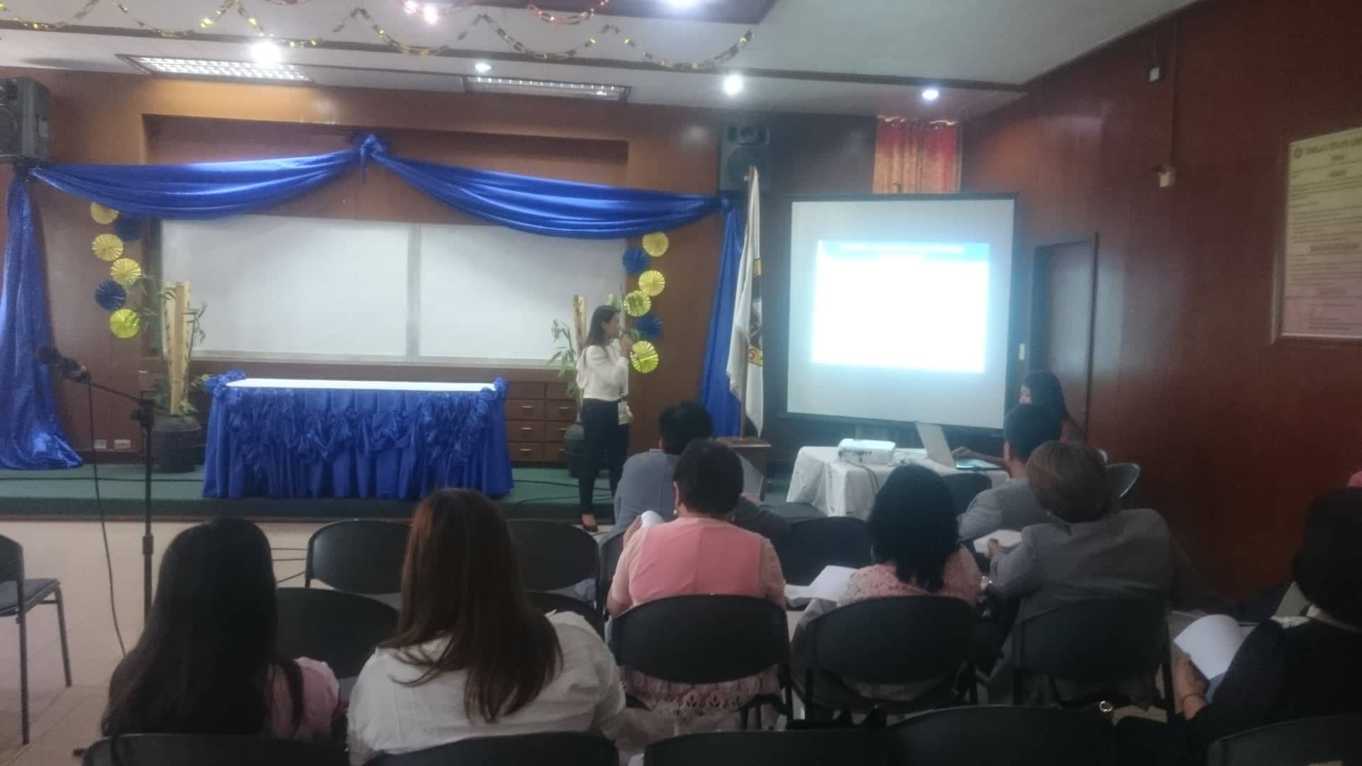

Ms. Suzane Cruz of the University Research Office presenting the background and overview of the research agenda setting.

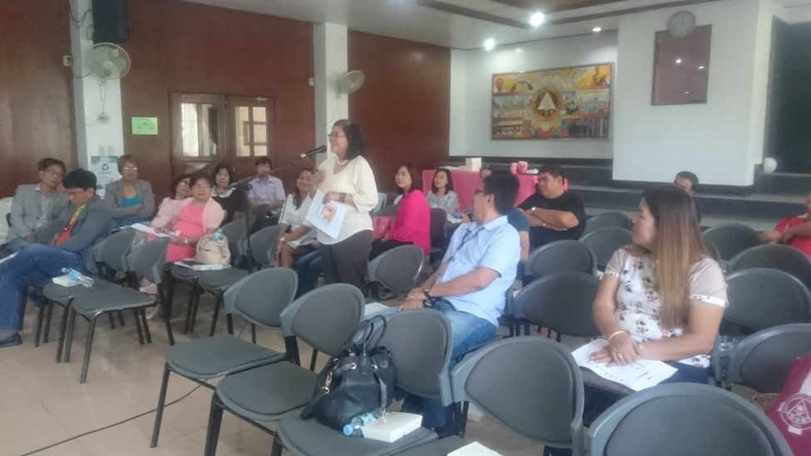

Dr. Lilybeth B. Laranang of the Tarlac Agricultural University presenting her inputs for TSU’s Proposed Research Agenda.

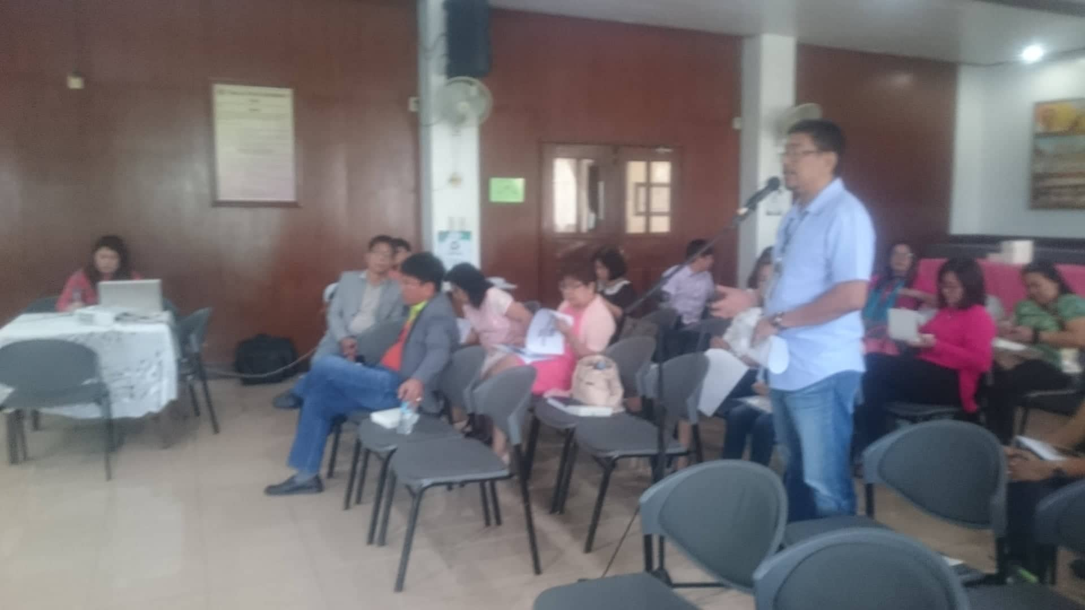

Mr. Romeolito G. Tacbian of Department of Science and Technology presenting his inputs for TSU’s Proposed Research Agenda

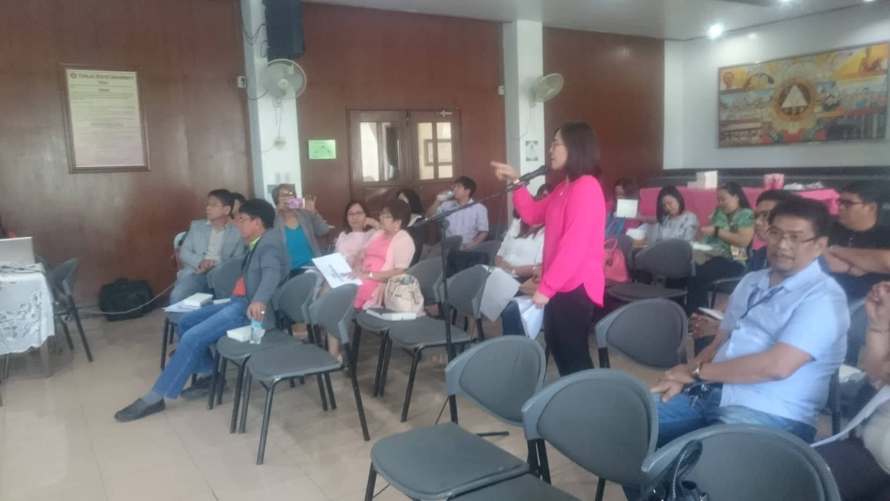

Dr. Rita Pulmano of the Center for Gender and Development presenting her inputs for TSU’s Proposed Research Agenda

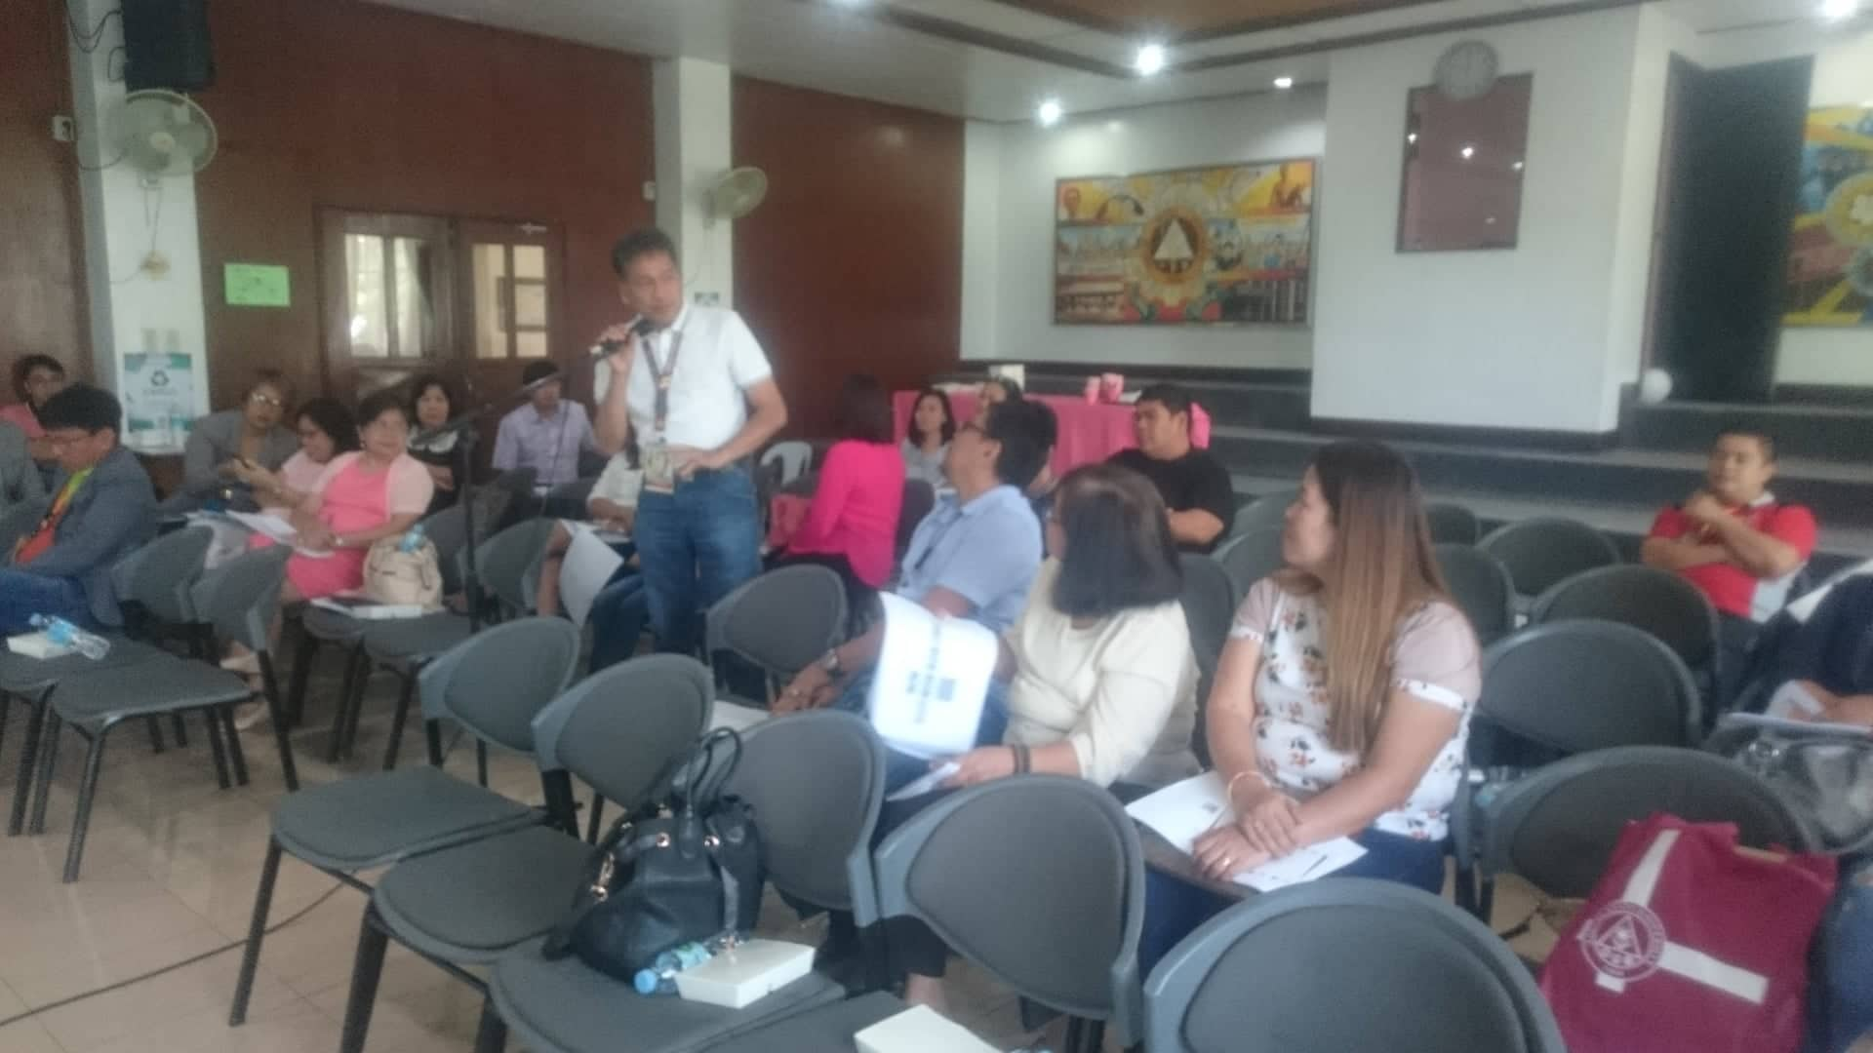

Prof. Redemptor Toledano of the University Extension Services Office presenting his inputs for TSU’s Proposed Research Agenda

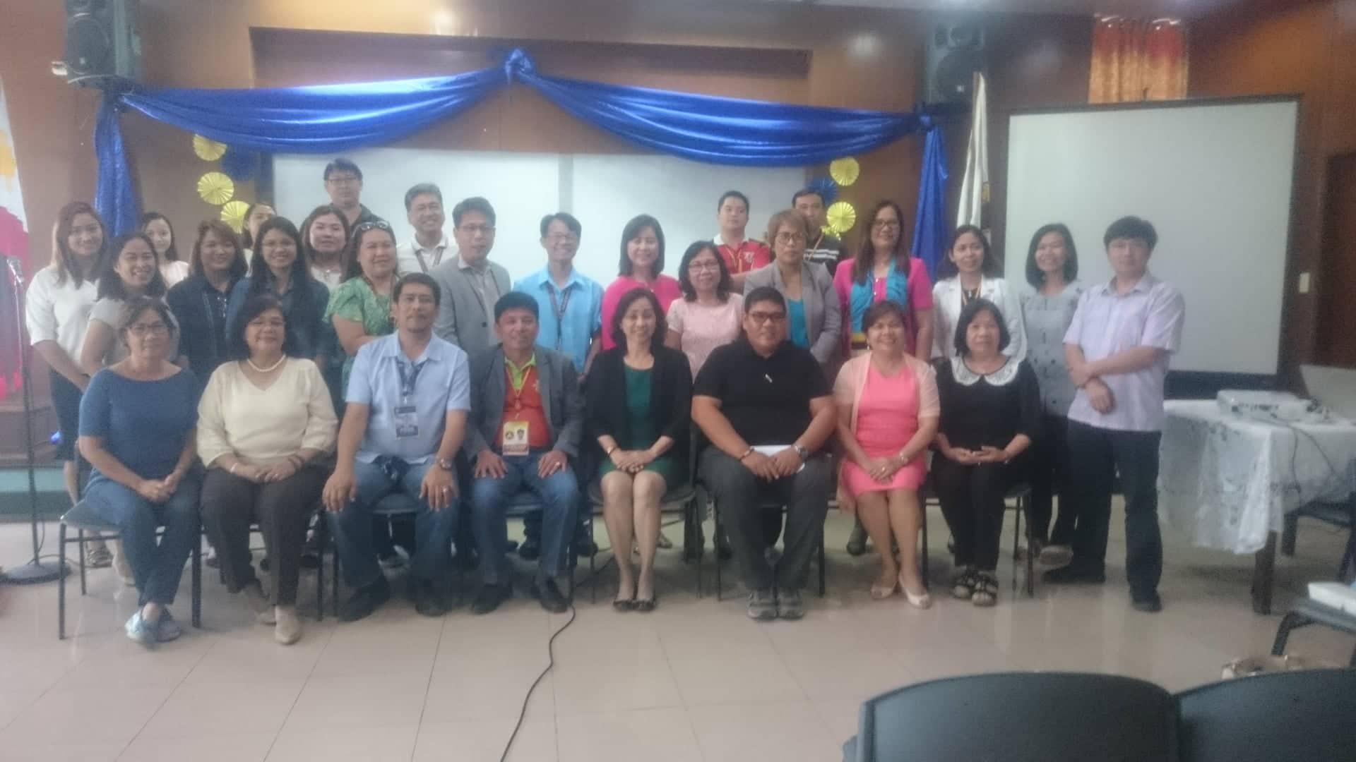

Group Pictures of the Participants during the Research Agenda Setting of the Tarlac State University